Trends

# Overall Trends

* More technological developed sensors
* Health and well-being
* Natural disasters in dense population
* New ways of working

# Li-Fi: Internet using light

Li-Fi (Light Fidelity) uses visible light communication

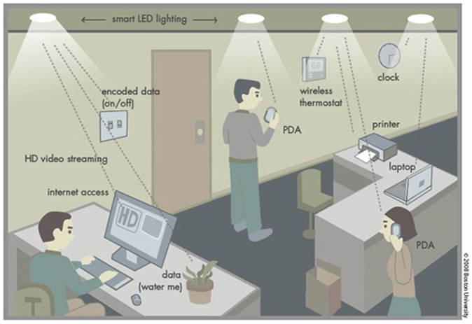

Philips lighting company has developed a VLC system for shoppers at stores. They have to download an app on their smartphone and then their smartphone works with the LEDs in the store. The LEDs can pinpoint where they are located in the store and give them corresponding coupons and information based on which aisle they are on and what they are looking at.

# E-glass

Tinting window depending on sunlight. Means blinds and shutters are no longer needed.

# LeakSmart

A central connected to the main water source turns off the water automatic when there is a leak detected by one of the sensors

# Rändivoo

Manage building access using beacons.

# Scanalytics Floor Sensors

Scanalytics- connected floor sensors measure foot traffic for consumer behaviour insights. Similar to a touchscreen on the floor, the -SoleSensors- measure every step in the customer journey and simplifies these insights into interactive heat maps and figures through an online dashboard.

<http://iotawards.postscapes.com/winners/2015-16-iot-award-winners>

<http://postscapes.com/internet-of-things-award/winners/>

http://servicefutures.com/facility-management/9-megatrends-facility-management/